Power Of Three
Platform: Leetcode
Language: C
Module 5, Question 2

Problem Link
https://leetcode.com/problems/power-of-three/

Problem Statement
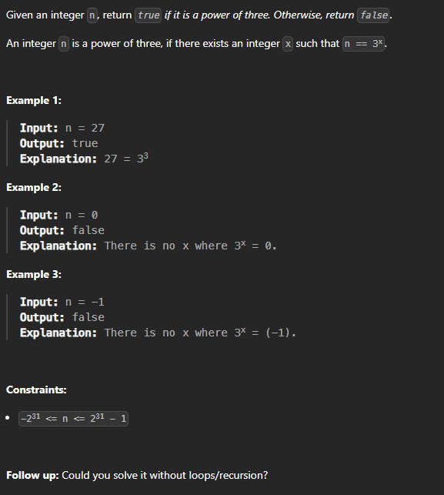

C Code
bool isPowerOfThree(int n) {
if (n <= 0) return false;
while (n % 3 == 0)
n /= 3; // divide out every factor of 3
return n == 1; // a power of three ends at exactly 1
}

Screenshot of Successful Submission



